2015 Applied Maths Higher Level Questions
1.
(a)
A particle starts from rest and moves with constant acceleration.
If the particle travels 39 m in the seventh second, find the distance travelled in the tenth second.

(b)
A train of length 66.5 m is travelling with uniform acceleration $\frac{4}{7}$ m s^{–2}.
It meets another train of length 91 m travelling on a parallel track in the opposite direction with uniform acceleration $\frac{8}{7}$ m s^{–2}.
Their speeds at this moment are 18 m s^{–1} and 24 m s^{–1} respectively.
- Find the time taken for the trains to pass each other.
- Find the distance between the trains 1 second later.

2.
(a)
Two cars, A and B, travel along two straight roads which intersect at an angle of 135°.
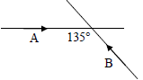
Car A is moving towards the intersection at a uniform speed of 60 km h^{–1}.
Car B is moving towards the intersection at a uniform speed of 45 km h^{–1} and it passes the intersection 2 minutes after A.
- Find the magnitude and direction of the velocity of B relative to A.
- Find the shortest distance between the cars.

(b)
A woman falling vertically by parachute in a steady downpour of rain observes that when her speed is 5 m s^{–1} the rain appears to make an angle 45° with the vertical.
When her speed is 3 m s^{–1} the rain appears to make an angle 30° with the vertical.
Find the magnitude and direction of the velocity of the rain.

3.
(a)
A tennis player, standing at P, serves a tennis ball from a height of 3 m to strike the court at Q.
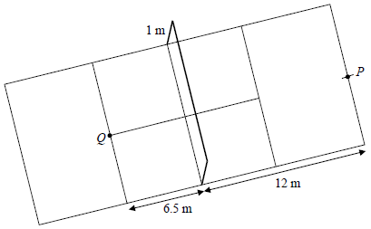
The speed of serve is 50 m s^{–1} at an angle β to the horizontal.

- Find the two possible values of tan β.
- For each value of tan β find the time, t, it takes the ball to reach Q.
- If the tennis player chooses the smaller value of t, by what distance does the ball clear the net?

(b)
A plane is inclined at an angle of 30° to the horizontal.
A particle is projected up the plane with initial speed u m s^{–1} at an angle θ to the inclined plane.
The plane of projection is vertical and contains the line of greatest slope.
If the particle strikes the inclined plane at right angles, show that the time of flight of the particle is $\frac{4\sqrt{7}u}{7g}$ .

4.
(a)
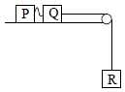
Two particles P and Q, of mass 4 kg and 7 kg respectively, are lying 0.5 m apart on a smooth horizontal table.
They are connected by a string 3.5 m long. Q is 6 m from the edge of the table and is connected to a particle R, which is of mass 3 kg and is hanging freely, by a taut light inextensible string passing over a light smooth pulley.
The system is released from rest.
Find
- the initial acceleration of Q and R
- the speed of Q when it has moved 3 m
- the speed with which P begins to move.

(b)
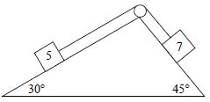
A wedge of mass 11 kg is held on the ground with its base horizontal and smooth faces inclined at 30° and 45° respectively to the horizontal.
A 5 kg mass on the face inclined at 30° is connected to a 7 kg mass on the other face by a light inextensible string which passes over a smooth light pulley.
The system is released from rest and the wedge does not move.
Find
- the acceleration of the particles
- the vertical force exerted on the ground.

5.
(a)
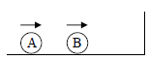
A small smooth sphere A, of mass 2m, moving with speed 9u m s^{–1}, collides directly with a small smooth sphere B, of mass 5m, which is moving in the same direction with speed 2u m s^{–1}.
Sphere B then collides with a vertical wall, rebounds and collides again with sphere A.
The wall is perpendicular to the direction of motion of the spheres.
The first collision takes place 35 cm from the wall.
The coefficient of restitution between the spheres is $\frac{4}{5}$ .
The coefficient of restitution between sphere B and the wall is $\frac{5}{14}$ .
- Show that, as a result of the first collision, A comes to rest.
- Find the time between the two collisions between A and B in terms of u.
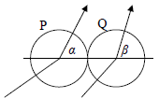
(b)
Two identical smooth spheres, P and Q, collide.
The coefficient of restitution is 1.
The velocity of P before impact is a i + b j and the velocity of Q before impact is c i + d j, where i is along the line of the centres of the spheres at impact.
After impact the direction of motion of P makes an angle α with their line of centres and the direction of motion of Q makes an angle β with their line of centres.
Show that tan α tan β = $\frac{bd}{ac}$ .

6.
(a)
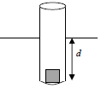
A loaded test-tube of total mass m floats in water and is in equilibrium when a length d is submerged, as shown.
The upward force exerted by the water on the test-tube is F.
- Given that F is directly proportional to the submerged length, find the constant of proportionality in terms of d, m and g.
- The test-tube is now pushed down a small amount and then released.
Show that it will oscillate with simple harmonic motion, and find the period of the motion.

(b)
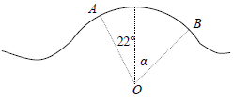
A skier of mass m kg is skiing on a hillside when he reaches a small hump in the form of an arc AB of a circle centre O and radius 7 m, as shown in the diagram.
O, A and B lie in a vertical plane and OA and OB make angles of 22º and α with the vertical respectively.
The skier’s speed at A is 8 m s^{–1}.
The skier looses contact with the ground at point B.
Find the value of α.

7.
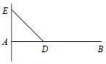
(a)
A uniform beam AB of length 3l and weight W is free to turn in a vertical plane about a hinge at A.
The beam is supported in a horizontal position by a string attached to the beam at D and to a point E which is at a height c vertically above A.
If AD = l, find in terms of W, l and c
- the tension in the string
- the magnitude of the reaction at the hinge.

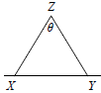
(b)
Two uniform rods, XZ and YZ, of equal length, are freely jointed at Z, and rest in equilibrium in a vertical plane with the ends X and Y on a rough horizontal plane.
The weight of XZ is 2W and the weight of YZ is W.
- Find the normal reaction at X and the normal reaction at Y.
- Show that as θ increases, slipping occurs at Y before X.
- Find the coefficient of friction if YZ is on the point of slipping when θ = 90°.

8.
(a)
Prove that the moment of inertia of a uniform rod, of mass m and length 2l, about an axis through its centre, perpendicular to its plane, is $\frac{1}{3}$ ml².

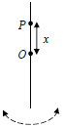
(b)
A uniform rod, of length one metre and with centre O, oscillates about a horizontal axis through P, which is a distance x from O.
- Find, in terms of x, the length of the equivalent simple pendulum.
- Find the value of x for which the period of oscillation is a minimum.
- Find the minimum period of oscillation.

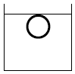
9.
(a)
A hollow spherical copper ball just floats in water completely immersed.
The external diameter of the ball is 8 cm and the internal diameter is 7.68 cm.
Find the density of the copper.
[Density of water = 1000 kg m^{–3}]

(b)
A ship, of mass 6500 tonnes, is observed to sink 0.375 m in sea-water when loaded with M tonnes of cargo.
The cross-sectional area of the ship at the water-line is 1250 m². The sides of the ship near to the water-line are vertical.
The density of sea-water is 1030 kg m^{–3}.
- Find M.
- How far will the ship (including cargo) sink when passing from sea-water to fresh-water, which has a density of 1000 kg m^{–3}?

10.
(a)
Two cars, A and B, start from rest at O and begin to travel in the same direction.
The speeds of the cars are given by v_{A} = t² and v_{B} = 6t ‒ 0.5t², where v_{A} and v_{B} are measured in m s^{–1} and t is the time in seconds measured from the instant when the cars started moving.
- Find the speed of each car after 4 seconds.
- Find the distance between the cars after 4 seconds.
- On the same speed-time graph, sketch the speed of A and the speed of B for the first 4 seconds and shade in the area that represents the distance between the cars after 4 seconds.

(b)
A company uses a cost function C(x) to estimate the cost of producing x items.
The cost function is given by the equation C(x) = F + V(x) where F is the estimate of all fixed costs and V(x) is the estimate of the variable costs (energy, materials, etc.) of producing x items.

$\frac{dC}{dx}$ = M(x) is the marginal cost, the cost of producing one more item.
A certain company has a marginal cost function given by M(x) = 74 +1.1x + 0.03x².
- Find the cost function, C(x).
- Find the increase in cost if the company decides to produce 160 items instead of 120.
- If C(10) = 3500, find the fixed costs.

